**Master SpringBoot**

**12-SpringBoot Actuator:**

**Step-00: Introduction to Actuator**

**Step-01: New GIT branch (using IDE)**

* **Git Branch name: 13-SpringBoot-Actuator**
* **Create new local branch**

**Step-02: Add SpringBoot Actuator Dependency in pom.xml**

**<dependency>**

**<groupId>org.springframework.boot</groupId>**

**<artifactId>spring-boot-starter-actuator</artifactId>**

**</dependency>**

* **Verify the endpoint**
  + [**http://localhost:8080/actuator**](http://localhost:8080/actuator)
* **Only 2 endpoints**
  + **health**
  + **info**
* **Other Endpoints (full details)**
  + [**https://docs.spring.io/spring-boot/docs/current/reference/html/actuator.html#actuator.endpoints**](https://docs.spring.io/spring-boot/docs/current/reference/html/actuator.html#actuator.endpoints)

**Step-03: Expose all Actuators endpoints.**

* **Application.properties**
  + **Management.endpoints.web.exposure.include=\***
* **Restart Embedded Tomcat**
* **Verify the endpoints**
  + [**https://localhost:8080/actuator**](https://localhost:8080/actuator)
* **Health Endpoint**
  + **Management.endpoint.health.show-details=always**

**Step-04: Info Endpoint**

* **Retrieve Build Properties**
  + **Update pom.xml**

**<plugin>**

**<groupId>org.springframework.boot</groupId>**

**<artifactId>spring-boot-maven-plugin</artifactId>**

**<executions>**

**<execution>**

**<id>build-info</id>**

**<goals>**

**<goal>build-info</goal>**

**</goals>**

**</execution>**

**</executions>**

**</plugin>**

* **Actuator automatically provides Environment Properties which starts with info in application.properties**
  + **Info.greettings=Good Morning and Hello World**
* **Info endpoint can gather properties from many spring boot externalized sources**
  + [**https://docs.spring.io/spring-boot/docs/current/reference/html/boot-features-external-config.html**](https://docs.spring.io/spring-boot/docs/current/reference/html/boot-features-external-config.html)

**Step-05: Metrics Endpoint**

* **Metrics**
  + [**http://localhost:8080/acuator/metrics**](http://localhost:8080/acuator/metrics)
  + [**http://localhost:8080/acuator/metrics/jvm.memory.used**](http://localhost:8080/acuator/metrics/jvm.memory.used)
  + [**http://localhost:8080/acuator/metrics/jvm.threads.states**](http://localhost:8080/acuator/metrics/jvm.threads.states)
  + [**http://localhost:8080/acuator/metrics/https.server.requests**](http://localhost:8080/acuator/metrics/https.server.requests)

**Check in cleaned up code, removed imports not used:**

**git status git add . git status**

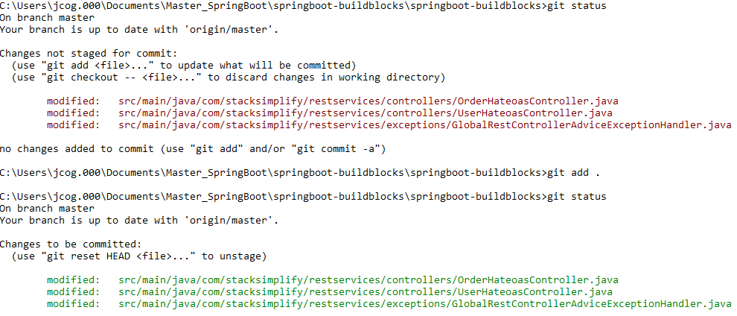

**git commit –m “Cleaned up code”**



**git checkout –b 13-SpringBoot-Actuator**



**Add dependency:**



**Test for actuator:**

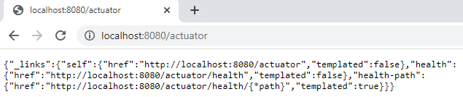

**Use browser extensions for pretty print**

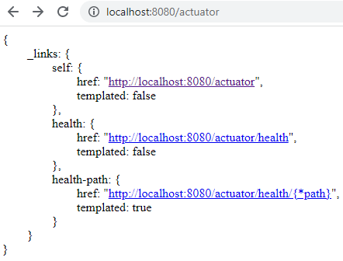

**Available endpoints:**

[**https://docs.spring.io/spring-boot/docs/current/reference/html/actuator.html#actuator.endpoints**](https://docs.spring.io/spring-boot/docs/current/reference/html/actuator.html#actuator.endpoints)

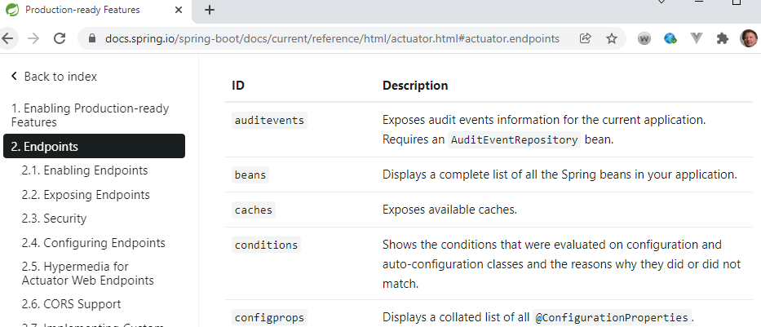

**Show the health status:**

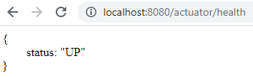

**Expose all endpoints using application.properties:**

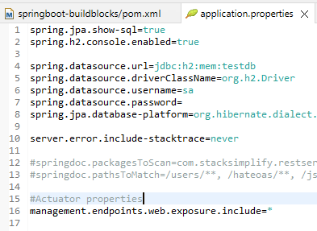

**Show endpoints again:**

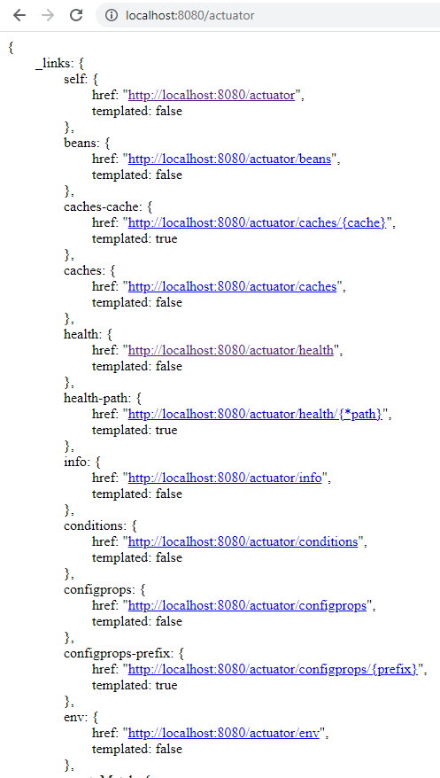

**Set the Health Endpoint explicitly with application.properties:**

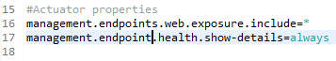

**Health endpoint has expanded:**

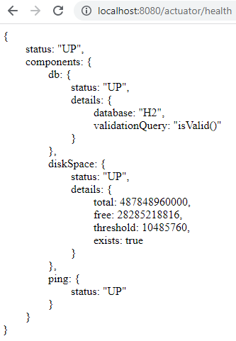

**Check info before pom.xml dependencies added:**

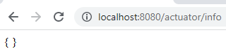

**Add dependencies:**

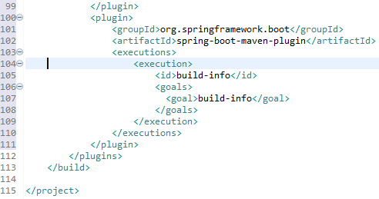

**Now, check the info status:**

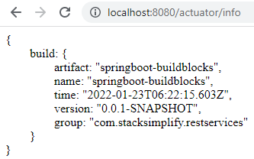

**Add custom properties on info:**

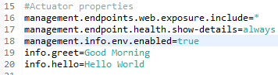

**Check the info status:**

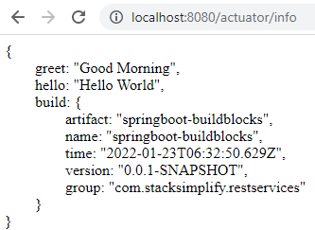

**Test metrics urls:**

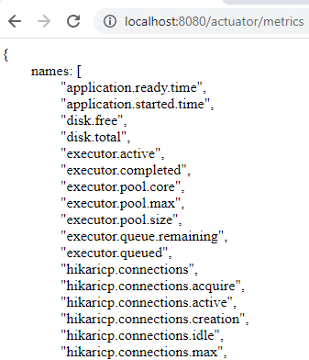

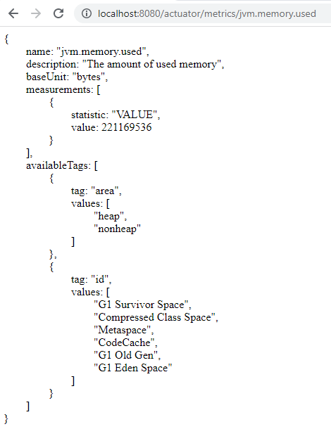

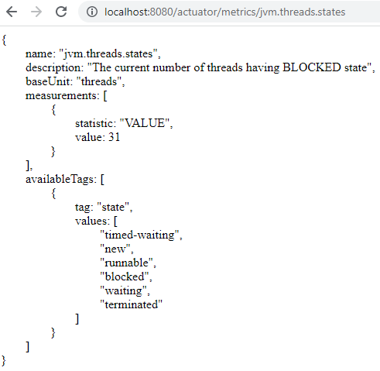

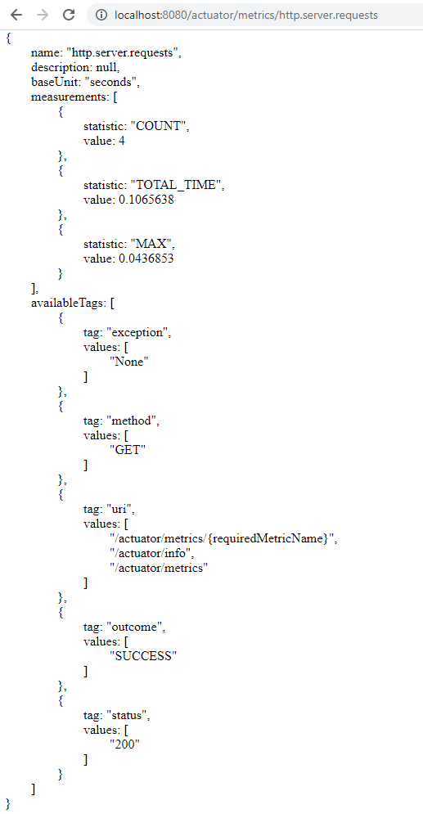

**Now, remove * from includes (application.properties) and specify only “health, info, metrics”**

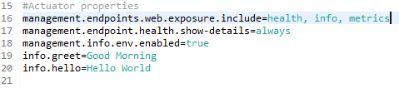

**Show output:**

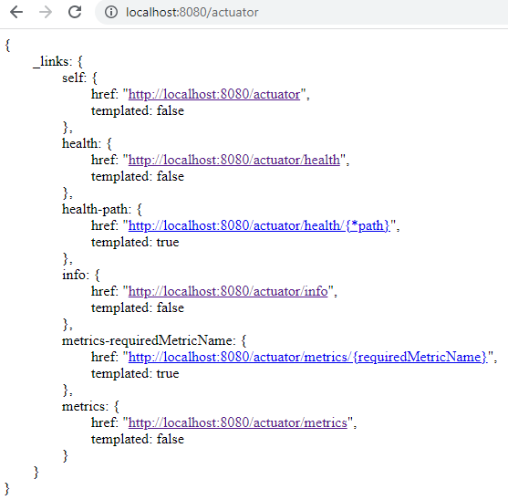

**Step-01: SpringBoot Admin server – Base project setup**

* **Create new SpringBoot Project from SpringBoot Initializer**
* **Add Dependencies**

**<dependency>**

**<groupId>de.codecentric</groupId>**

**<artifactId>spring-boot-admin-starter-server</artifactId>**

**<version>2.6.2</version>**

**</dependency>**

* **Annotate with @EnableAdminServer for SpringBoot main application class file**
* **Change the port to 9080**
  + **application.properties – server.port=9080**
* **Access SpringBoot Admin server**
  + [**http://localhost:9080**](http://localhost:9080)
* **References**
  + [**http://codecentric.github.io/spring-boot-admin/2.1.6/#getting-started**](http://codecentric.github.io/spring-boot-admin/2.1.6/#getting-started)

**Step-02: Point SpringBoot Client Application (SpringBoot-BuildingBlocks project)**

* **Add SpringBoot Admin Client dependency**

**<dependency>**

**<groupId>de.codecentric</groupId>**

**<artifactId>spring-boot-admin-starter-client</artifactId>**

**<version>2.6.2</version>**

**</dependency>**

* **application.properties**

**Create the new springboot project directly from the IDE:**

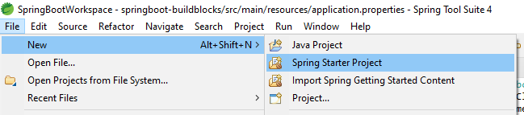

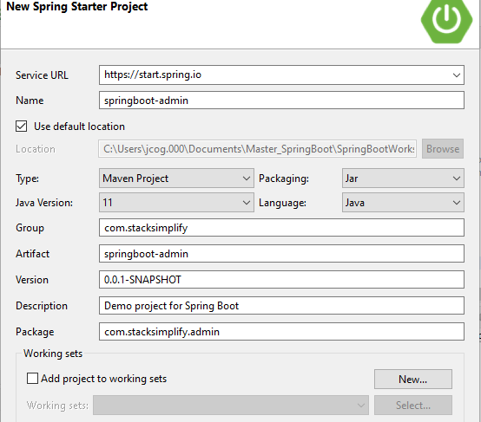

**Next**

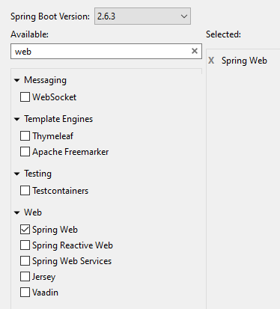

**Next**

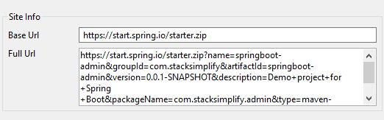

**Finish**

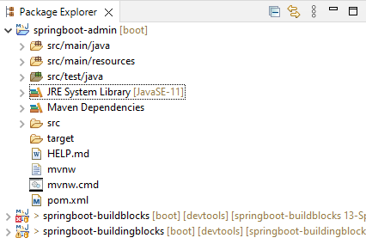

**Change server port for Admin Server:**

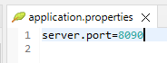

**Add dependency for Admin Server:**

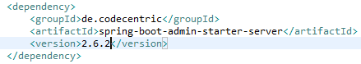

**Add annotation to the SpringBootApplication class:**

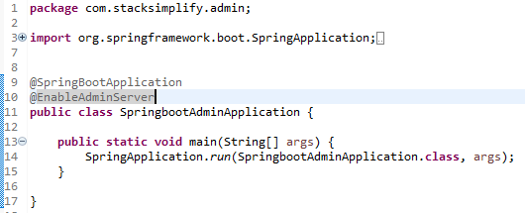

**Try the web url:** [**http://localhost:8090**](http://localhost:8090) **(Make sure the other server is down)**

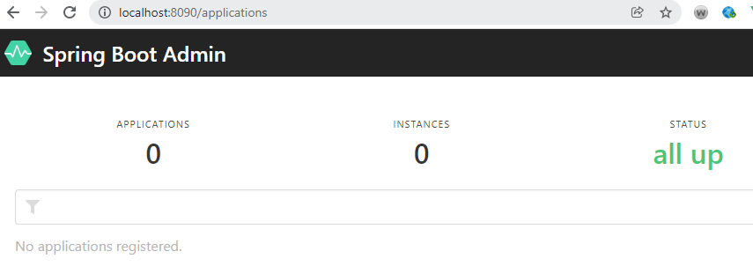

**Creating the client to the admin server:**

**Add dependency to pom.xml file for the springboot-buildingblocks application:**

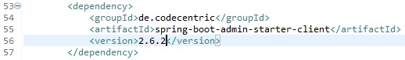

**Add entries to the application.properties file:**

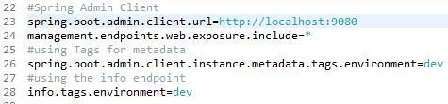

**Restart both client and server:**

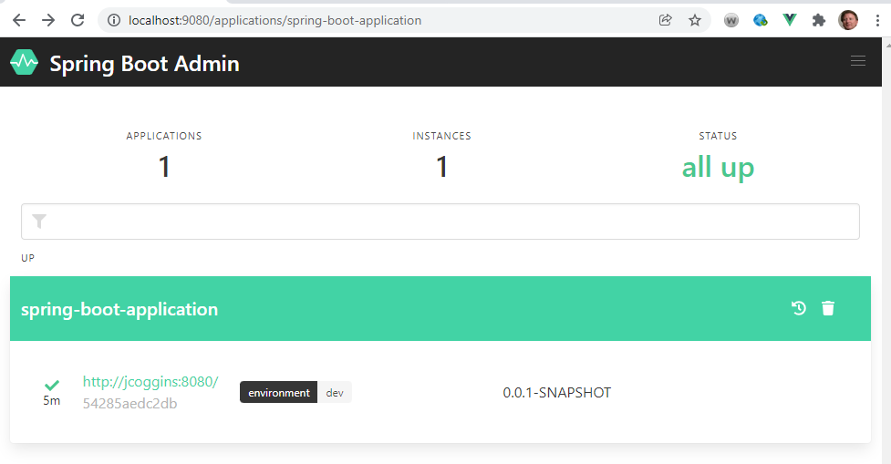

**Select the black environment button:**

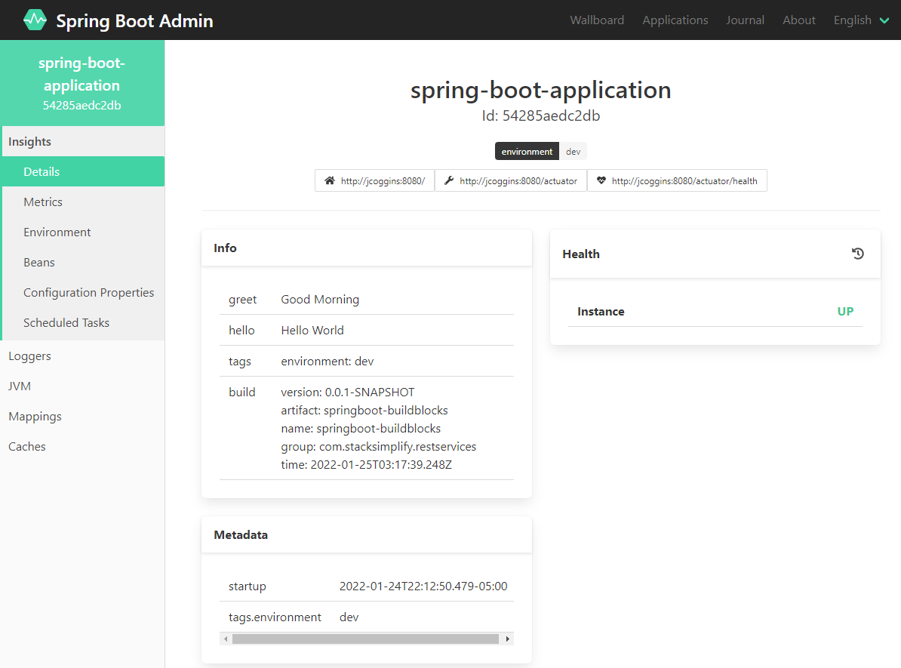

**Show the metrics by selecting Metrics:**

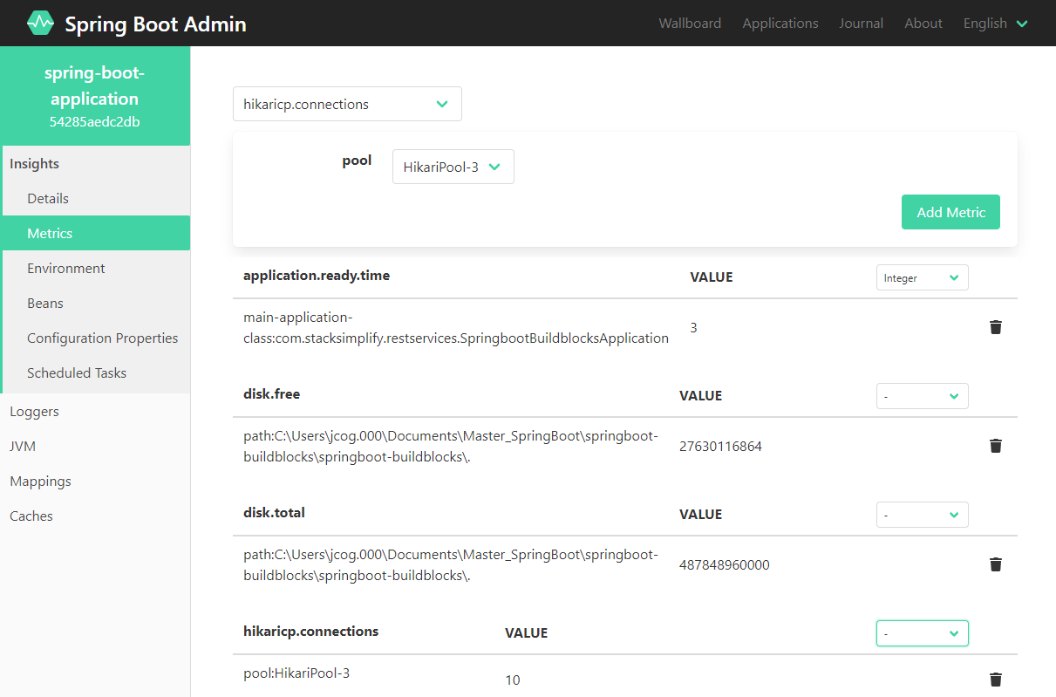

**Metrics are live and always changing so history is not possible:**

**Loggers is good for managing the application**

**Mappings are available for all endpoints:**

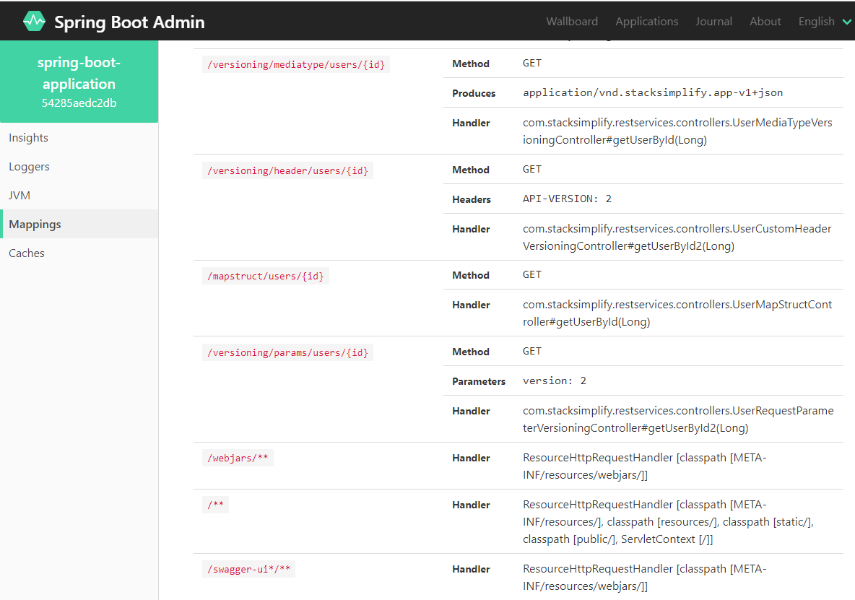

**You can create load tests with Postman and the details will show in the SpringBoot Admin:**

**git status git add . git status**

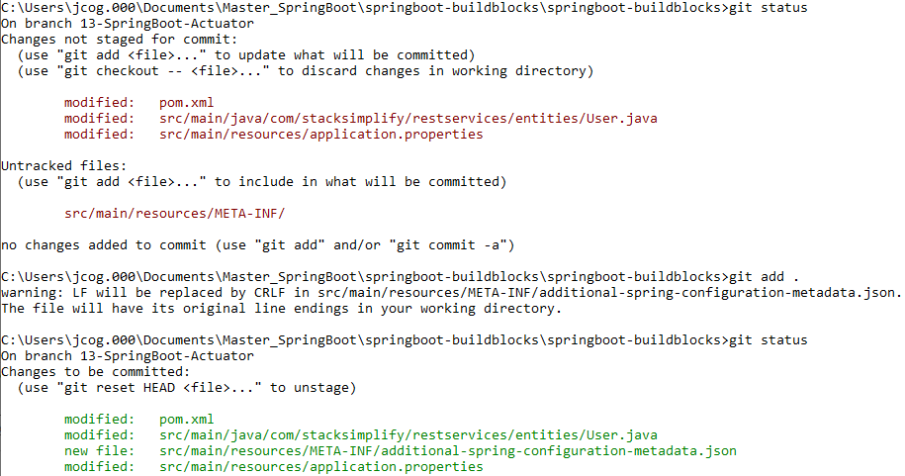

**git commit –m “First Commit”**



**git push origin --set-upstream 13-SpringBoot-Actuator**

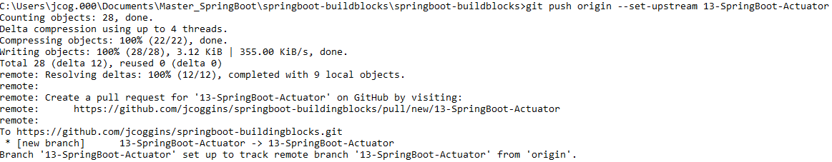

**git checkout master git merge 13-SpringBoot-Actuator**

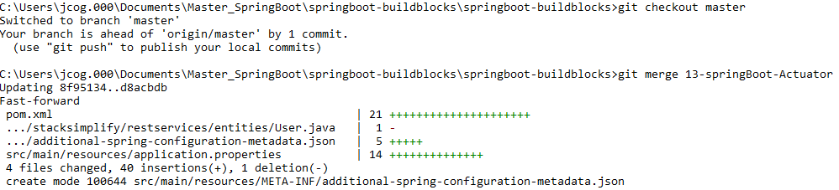

**git push**



**git branch –vva**

